**[HacknSlash]**

# **Project Description**

Mobile 2.5d game made with Unreal Engine 4. There are levels where you go through beating up mobs. Once you reach the third level of an area you will face a boss. The player will be able to pick up items and weapons. Depending on the item it will get picked up automatically or it will ask the player to pick up the object. The game will be low poly so that it will run efficiently on Android and iPhone. This game is intended for people 13 and up since there will be cartoon violence.

# **Part 1: Non-Functional Requirements**

1. The game is going to be published on Android/Apple
   1. Will require a mac to publish to IOS.
   2. IPhone 5 iOS 10.
   3. Android 5.1 Lollipop.
   4. Using basic lighting in Unreal (second tier of lighting performance) compatible with iPhone 5
2. The system will be thoroughly tested prior to delivery.
   1. At Least 3 User Testers
3. Frame rate should average no less than 30fps

# **Part 2: Functional Requirements**

## **Glossary**

Before formally defining the functional requirements, it is necessary to define the domain-specific terminology to avoid confusion or ambiguity.

* “Pickups” – Items that the player character will move over and receive different benefits from.
* “Spawn System” - The criteria for when and where enemies will be loaded into the stage. This will vary as different enemies will be in different places on different levels.

## **Priority**

Each requirement has a priority level of [1], [2], or [3].

1. Must-have functionality critical to the problem solution.

2. Highly desirable feature that should be included.

3. Optional requirements that will be completed if time allows.

## **Pickups**

1. A Player can move over a pickup and add it to their inventory.
   1. Health Pickup [1]
   2. Different Weapons [1]
   3. Shield pickup [1]
   4. Gold [3]
   5. Speed/Damage Boost [3]

## **Enemy**

1. Can move left and right as well as up and down [1]
2. Dying [1]
3. Jumping [2]
4. Attack the player. [1]

## **Player**

1. Player can move left and right as well as up and down [1]
2. Can Jump (Unsure if there will be platforming) [2]
3. Shooting and Bashing [1]
   1. Machine Gun
   2. Bat
4. Swinging [3]
5. Stats
   1. Lives[1]
      1. Player will have 3 lives, will not be able to obtain more while playing.
   2. Health [1]
   3. Shield [1]
   4. Ammo Clip Size (Unlimited ammo) [2]

## **Environments**

1. Levels
   1. Neighborhood. [1]
      1. 3 Levels will take place in this environment, with the 3rd level being a boss battle.
      2. Map of area [3]
   2. Cemetery. [3]
   3. Swamp [3]

## **Game Over**

1. Player runs out of lives [1]
2. Player beats the final boss [1]

## **Score**

1. You get score for killing a mob [2]
2. Score for killing boss [2]
3. High Score Screen [2]
4. Score for picking up gold [3]
5. Timer [3]
6. Speed of beating level [3]

**Part 3: Basic Design**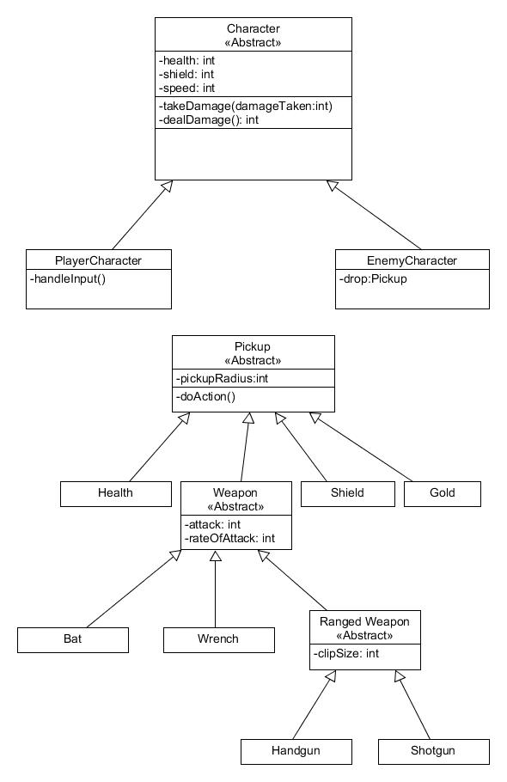

**Part 4: Project Plan**

**Week 1:**

80-90% UI Finished

1. Main Menu
   1. Play
   2. Options
   3. Exit
2. Options Menu
   1. Sound Settings
3. Pause Screen
   1. Resume
   2. Exit
4. Game Over/ Death Screen
5. Gameplay HUD
   1. Health
   2. Bullets
   3. Lives (maybe)

Enemy and Player Movement:

1. Enemy just needs to walk to player and deal damage no animations yet.
2. Player can walk around.

**Week 2:**

First Level Finished

1. Spawn System for Enemies Created.
2. 10-50 enemies spawning.
3. Level Completion Screen.
   1. Next Level.
   2. Main Menu.
   3. Score (maybe)
4. Enemies and Player have animations for swinging a bat.
   1. Collision on bat/ damage.
5. Player can Pick Up items.

Start Publishing Process for IOS and Google Play.

1. <https://docs.unrealengine.com/latest/INT/Platforms/iOS/QuickStart/index.html>
2. <https://docs.unrealengine.com/latest/INT/Platforms/Android/GettingStarted/index.html>

**Week 3:**

The next two levels are completed

New enemies

1. 1-3 new enemies.
2. Different weapons for the enemies.
3. Different color enemies (might be same model just different texture)

Playtest the game

1. Get 3 users to play in front of us.
2. Take notes on what could be improved.
3. Implement changes that people recommend.

**Week 4:**

If all other goals from previous weeks are met we will work on the following. This is the phase where we tie up our game and get everything polished.

* Add new Levels/Enemies if all other requirements are done.
* Implement more User tested changes if any.